Excellence in Clinical Teaching

Edward Hospital is known for its outstanding patient care and compassionate nursing staff. Please take a moment to recognize a staff nurse who exceeded your expectations for this clinical rotation.

Your name (optional)______________________________ Department:_____________________________
RN name:_______________________________

In this space please describe how the Edward Employee impressed you __________________________________________________________ __________________________________________________________ __________________________________________________________ __________________________________________________________ __________________________________________________________ __________________________________________________________ __________________________________________________________ __________________________________________________________ __________________________________________________________

We appreciate you taking the time to share your positive experience this semester! Please return this form to your clinical instructor.

Thank you,
Edward Hospital Professional Development Council

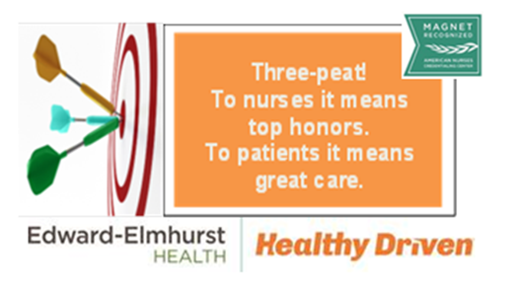
Instructors: Please be sure to email this form to: Margaret.Cross@eehealth.org

