Edward Hospital
APN Student Demographic Form

Please Print
Welcome to Edward Hospital! We look forward to helping you to have a positive clinical experience. Please complete the information below so you can be contacted if needed.

Today’s Date
Name
Address
Telephone
E-mail address
School
Faculty
Clinical experience
Hospital Preceptor
Dates of experiences
Total number of hours

The following items will need to be submitted prior to starting a clinical rotation (excluding Edward-Elmhurst employees):

 | Identifications |  |  | OSHA Compliance
 | Current Nursing License |  |  | Drug Screen
 | CPR Provider Card |  |  | Background Check
 | HIPAA |  |  | TB Test within 12 months
 | Immunizations: Measles, Mumps, Rubella, Varicella, TDap, Flu Vaccine (between October and March), Hepatitis.

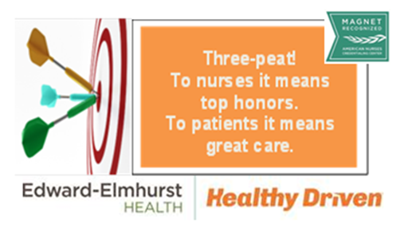
Email request to Margaret.Cross@eehealth.org

